january 2015
Volume I Issue 1


CONTENTS
1 CUPE CONNECTION JANUARY 2015
PAGE 1
Welcome
PAGE 2
President’s Message
Collective Agreement
Young Workers
PAGE 3
CUPE Member Highlight
2015 Executive
Behind the Scenes
PAGE 4
Health and Safety Tips
CUPE BC News
Events

Welcome to the 1st Edition of CUPE Connection!
By: Treena Harley
CUPE 3523 Support Staff - Central Okanagan School District No 23.
We would like to take this time to introduce our Local 3523 newsletter. In today’s fast-paced world, it may be difficult to attend general meetings or find enough time to discuss union matters with fellow CUPE members. CUPE Connection will keep you current with what’s happening within our bargaining unit.
Each issue will feature some regular columns. President Wendy Johnson will provide a message to members, and sections of the Collective Agreement will be highlighted with brief explanations to assist members in understanding our CA language. The first two issues will contain a summary of changes to our Collective Agreement that were negotiated last year.

We will also highlight a CUPE member and introduce them to our membership. Health and Safety topics will be presented with very important information and timely topics from CUPE BC or National will be showcased.
If you have any suggestions for an article you would like to see in CUPE Connection, please let us know.
Please email Treena Harley with your personal email address at 3523rs@telus.net if you would like to be included on the email list for CUPE Connection. (We can’t use the District system for Union business). This is the best way to view CUPE Connection as it will just arrive in your inbox. You can also access the newsletter at www.3523.cupe.ca and copies will be delivered to each worksite.
CUPE CONNECTION CONNCONNECTION
CUPE 3523 Flying Squad led by Darcy Egeland, brought treats and smiles to the BCTF picket lines.

President’s Message

It is with great pleasure that I welcome you to the first issue of our newsletter CUPE CONNECTION.
Your Union strives daily to ensure fairness, respect, equality and safety in the workplace, using the HYPERLINK "Docs%20for%20website/Equality%20Statement.pdf"
Equality Statement as our guiding principle.
Union solidarity over the past 51 plus years built the workplace we enjoy today. Participation and activism in the Union will maintain our workplace and build a better future for current members – and all those who will follow.
Come out to a General Meeting and get to know your Union. We’d love to meet you!
Enjoy reading the new newsletter. By working together in solidarity I know we will continue to grow and face whatever challenges lie ahead. 
In solidarity, Wendy Johnson
CUPE 3523

Contract Language Explained

2 CUPE CONNECTION JANUARY 2015
Collective Agreement – What we have just achieved
Our new Collective Agreement (CA) was fully ratified as of July 25, 2014. The terms of our agreement are in place from July 1, 2014 – June 30, 2019. The terms of this agreement will remain in place until such time as a new agreement is negotiated and ratified.
The Provincial Bargaining Team did an excellent job at the table, with wage increases in line with other public sector Unions, and the creation of the Essential Services Grant (ESG) that ensured we suffered no wage loss due to the strike of another Union (BCTF).
CUPE Local 3523 made significant improvements to our CA during this round of bargaining as well. Some of these improvements are:
- Increase to $1.50 per hour in lieu of benefits for temporary employees.
- Bus Driver waiting time can now be banked.
- The employer will pay employees their regular wage on the first day of injury.
- Relief Clerical employees will be paid at PG9 when covering for Administrative Secretary positions in elementary schools provided they have BCeSIS Basic, BCeSIS Level 1, Introduction to Admin Connect, and CIMS Web-Based Financial. If they do not have all of these qualifications, they will be paid PG4. For all other assignments, Relief Clerical will receive the rate of pay for that job, eg. BCeSIS in middle or high schools at PG5.
- Labour Market Adjustment – Carpenters and Plumbers were decreased $.15 per hour, and all other Trades were increased $.15 per hour.
- Bus Drivers will not be considered “declined” when assigning extra runs if they are absent for Funeral Leave, Bereavement, OH&S, Court Subpoenas, Jury Duty and Union Business.
■

YOUNG WORKERS

CUPE Young Workers are defined as employees who are 30 years and younger. Currently CUPE 3523 does not have a committee. If you are interested in starting up or joining the committee, please email President Wendy Johnson at 3523pres@telus.net
We would like to see the committee develop and maintain an active, educated young worker membership. The committee could also examine issues of particular concern to young workers. 


3 CUPE CONNECTION JANUARY 2015
CUPE BEHIND THE SCENES

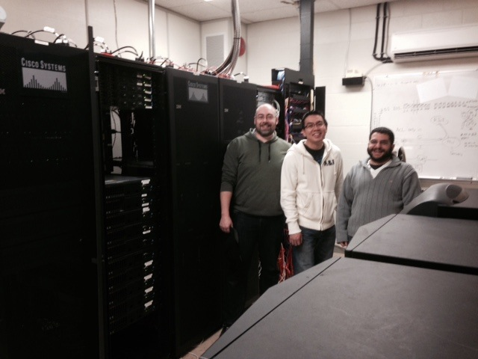
Chad Herbert, Ken Yew and Matt Loureiro
in the data centre. This houses all SD23’s
district servers and computer infrastructure.
The Learning Technology Department staff,
also known as ITs, are highly skilled and
trained workers.


Have you ever wondered what Central Stores looks like? Brad Raisanen sorts through a huge inventory. Central Stores orders are processed by the department and quickly delivered to all sites in SD23. Central Stores is an easy one-stop shop. 
CUPE Member Highlight – Myrna Flaman
By: Treena Harley
Who: Myrna Flaman, Transportation Coordinator. Myrna has been a bus driver, driver trainer and is now the transportation coordinator.
What: Myrna coordinates all bus drivers, bus routes and field trips. This job is 8 hours a day of very stressful work, yet Myrna always does it with a smile and attitude of helpfulness that make her a pleasure to have as a fellow CUPE sister.
Where: Operations is located on Dease Road.
When: Myrna started working for School District 23 just over 20 years ago. She has been the Transportation Coordinator for almost 7 years.
Why: Myrna is very passionate about her work. She feels very thankful that she has a job that she looks forward to every day. “Making sure that the children of SD23 arrive to and from school safely” is very important to Myrna. She also passes along to the drivers the importance of keeping the equipment, and more importantly the children safe. She has raised 3 wonderful children, Kelly, Wendy and David and understands the importance firsthand.
Highlight: Myrna’s mother in Regina has knitted hundreds of toques for school children. Myrna adopted that generosity and started knitting toques for premature babies at KGH. About 4 years ago, while searching on the internet, she came across a knitting pattern for a type of hat called a chemo cap. She had some friends that were going through treatment and she decided to donate her knitted efforts to the Kelowna Cancer Centre. There is a Chemo Cap Bank in Baltimore, MD that supports cancer centres all over North America and some of Myrna’s toques have made their way there. Thank you for all you do Myrna!

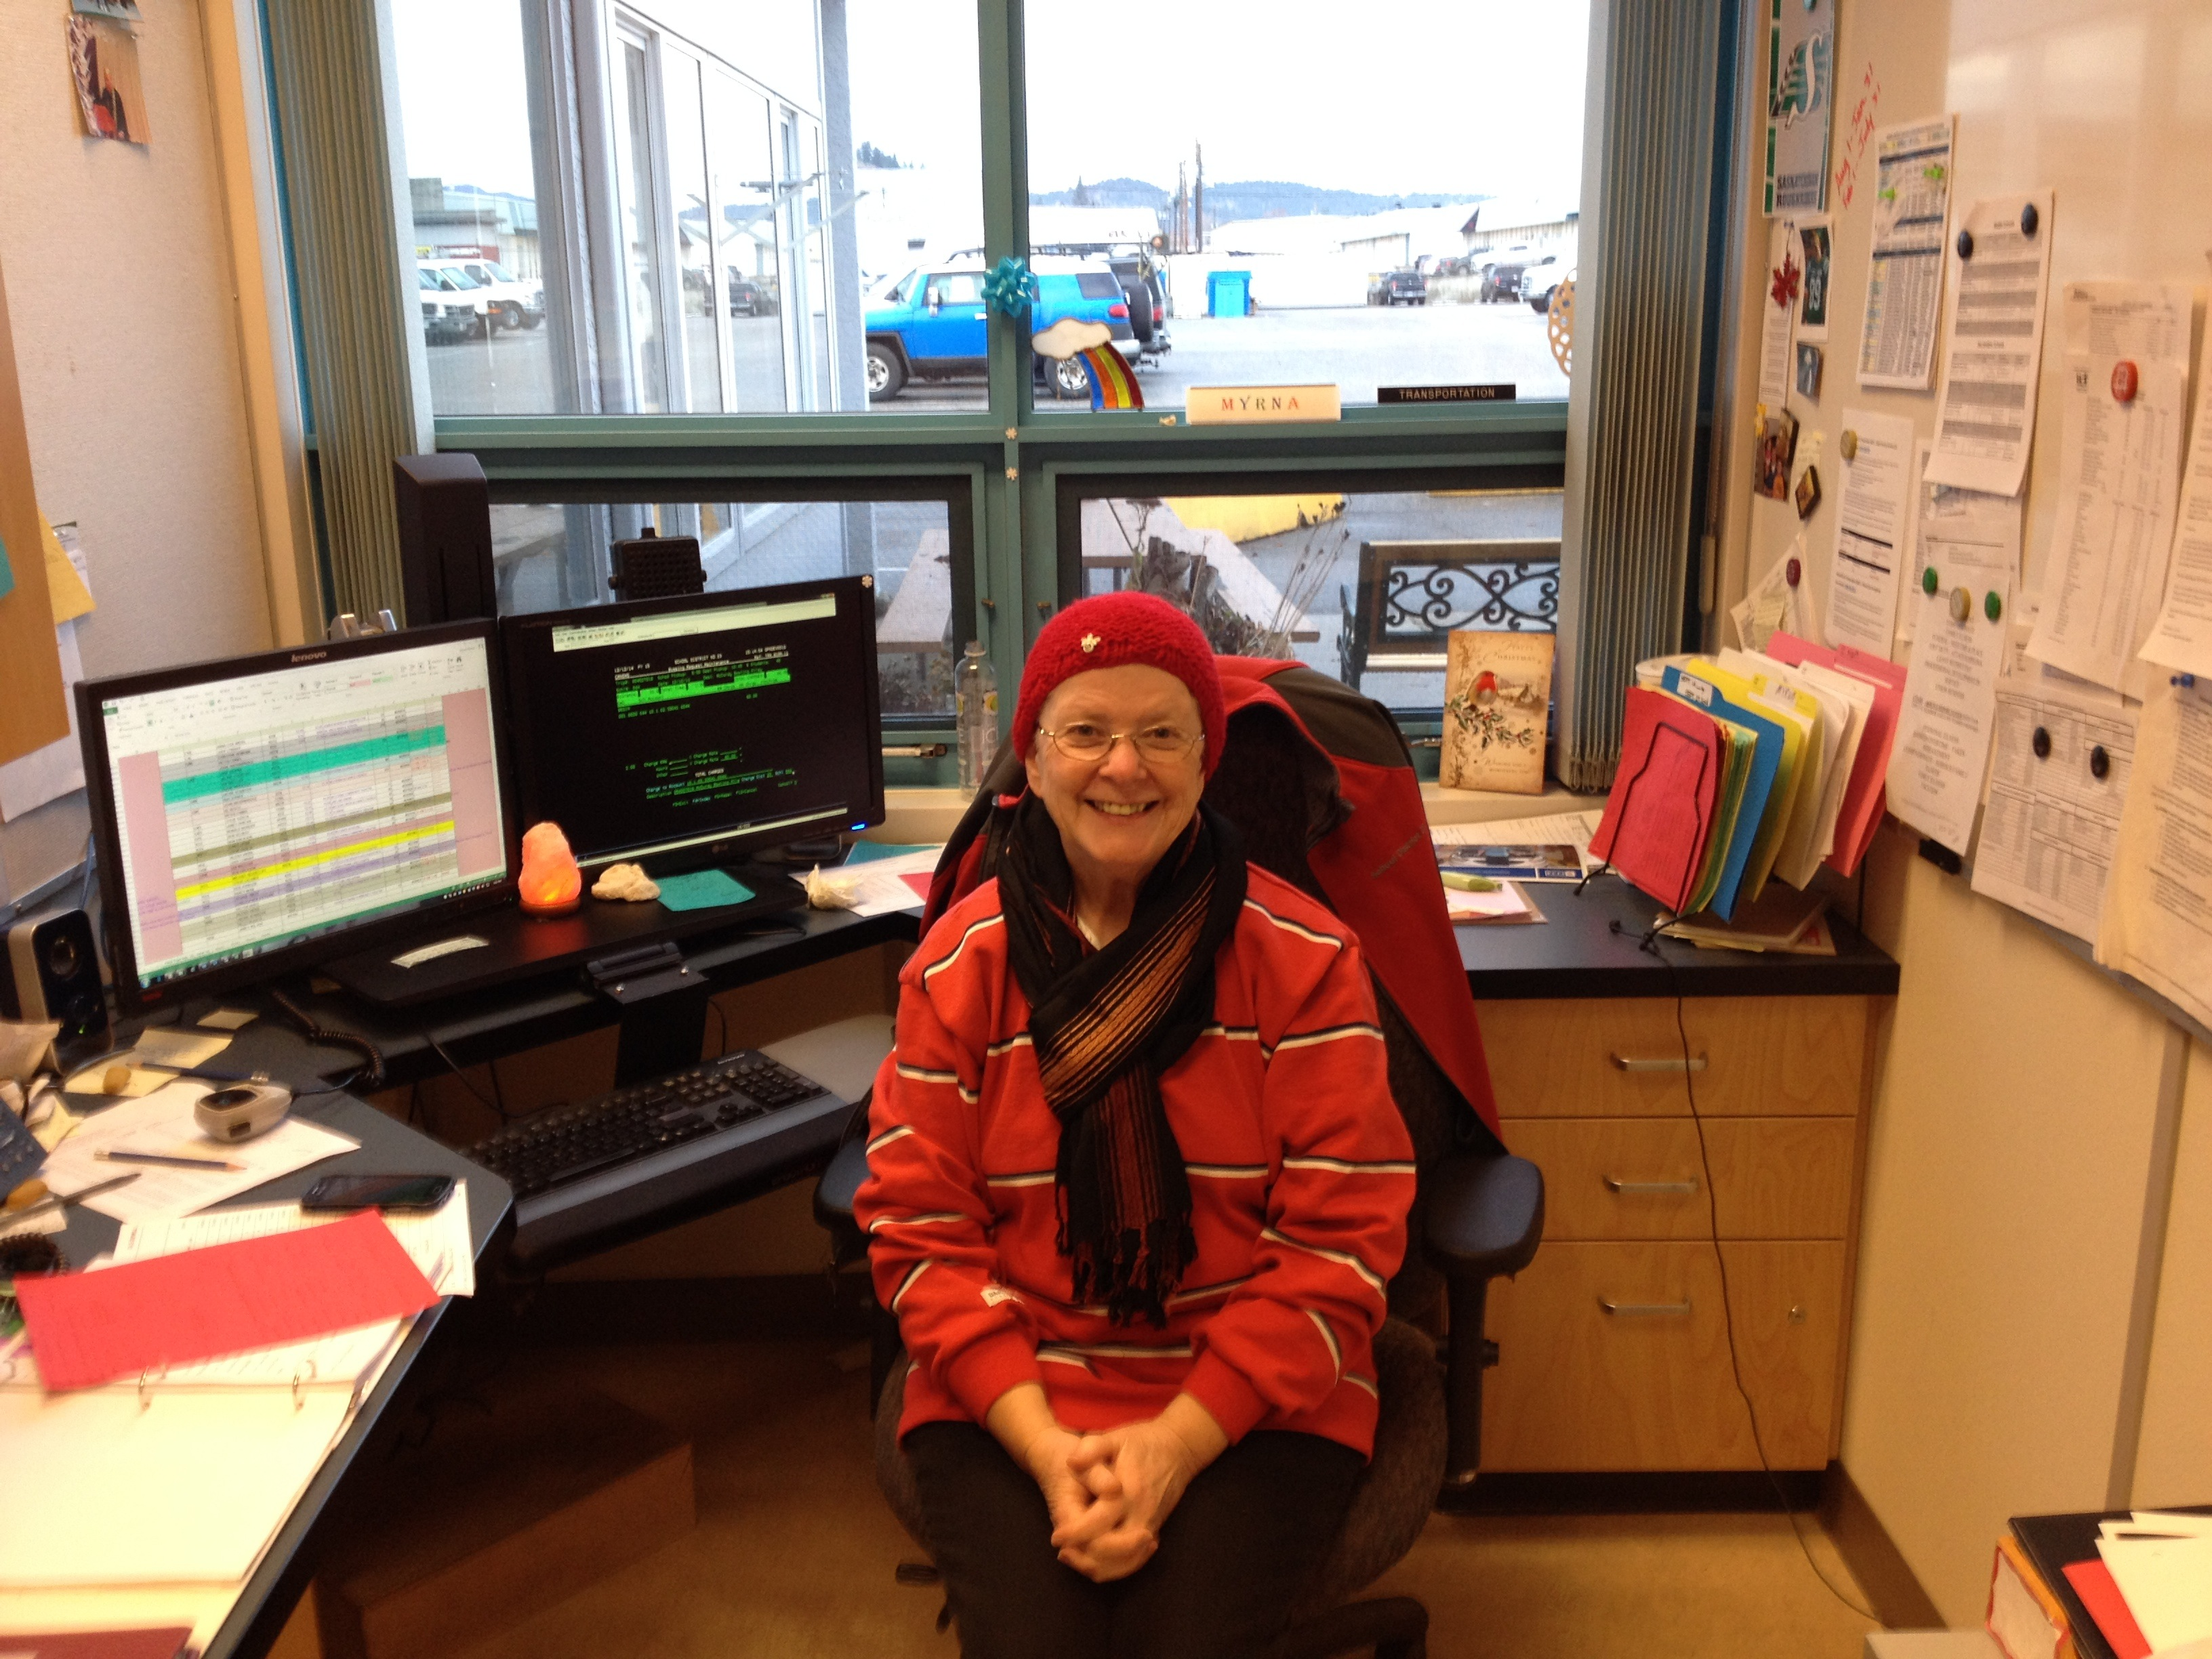
Myrna is wearing one of her chemo caps.
■

2015 EXECUTIVE

TABLE OFFICERS

PRESIDENT - Wendy Johnson
VICE PRESIDENT - David Tether
SECRETARY TREASURER - Kieran Fahy
RECORDING SECRETARY - Treena Harley

SHOP STEWARDS

SERGEANT AT ARMS - John O’Flaherty
OPERATIONS – Dick Beetlestone
CLERICAL/LIBRARY ASSISTANT – 2 vacant positions
TRANSPORTATION – Duane Wheatley
STUDENT SUPPORT – Margaret Varga and 1 vacancy
CUSTODIAL – Jim Anderson
GENERAL – Allan Miller

TRUSTEES
Ian Gordon
Sandra Ryan
Linda Christie

OFFICE CLERICAL – Shirley Fears
CUPE NATIONAL REP – Rob Hewitt

211 – 1889 Springfield Road
Kelowna, BC V1Y 5V5
250-860-3523

4 CUPE CONNECTION JANUARY 2015
Here’s what you can do if you have a health and safety problem.
Courtesy CUPE National’s health and safety website
1. Tell your supervisor.
In all Canadian jurisdictions, the respective occupational health and safety acts state that it is the primary duty of the employer to provide workers with a safe workplace. Your supervisor is the first link in a chain that goes to the top, so they need to be told about the hazards and dangers you discover in the workplace.
2. Tell others about the hazard.
Make sure your co-workers, your site health and safety committee and your local executive know about the hazard. It is the law that your employer must tell all employees about the hazards of the workplace, however not all do. To help protect each other, tell co-workers, especially those who will be potentially exposed to the hazard.

3. Your joint health and safety committee member.
Make sure your joint health and safety committee knows about the problem. All hazards should be reported to your CUPE rep on the JH&S committee. This is a particularly important step if your supervisor does not take action to fix the hazard. A well-functioning committee will address problems brought to its agenda, as well as conduct regular health and safety inspections to make sure that working conditions are safe. For more information on health and safety committees check out http://cupe.ca/health-and-safety.
4. District Support Staff Safety Advisory Committee.
If you do not have a CUPE rep for your joint health and safety site committee, please contact Treena Harley, co-chair at 3523rs@telus.net.




Health & Safety Tips
CUPE BC News
All CUPE K-12 Locals Ratify Collective Agreements
CUPE’s 57 K-12 Local bargaining committees have reached and ratified collective agreements, meeting the November 30, 2014 deadline.
“We’re pleased that all locals were able to conclude local bargaining issues by the November 30 deadline,” says K-12 Presdients’ Council Chair Marcel Marsolais. “Locals can now focus and look forward to the gains we achieved in this round of bargaining.”
Locals bargained individually with school districts to achieve local agreements that added to the provincial framework agreement ratified by the K-12 Presidents’ Council in June.
Sector coordinators John Horsfield and Rob Hewitt congratulated locals for finalizing bargaining.



Events
January 17, 2015
General Membership Meeting at
Hollywood Road Education Services
1040 Hollywood Road – Room 2
February 9, 2015
BC Family Day
February 20, 2015
Professional Development Day
March 7, 2015
General Membership Meeting at
Hollywood Road Education Services
1040 Hollywood Road – Room 2

